Q1)the program must accept a positive integer N and print the digit in the tenth position.

**Input Format:**

The first line denotes the value of N.

**Output Format:**

The first line contains the value of N.

**Boundary Conditions:**  
10 <= N <= 9999999

**Example Input/Output 1:**

Input:

20

Output:  
2

**Example Input/Output 2:**  
Input:  
37843

Output:

4

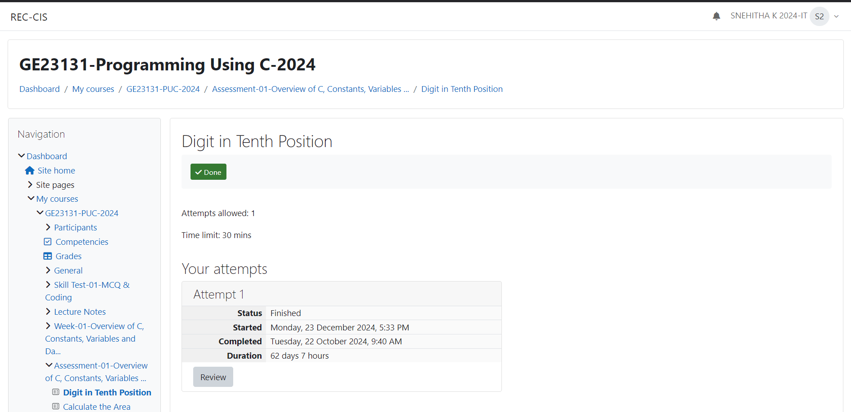s

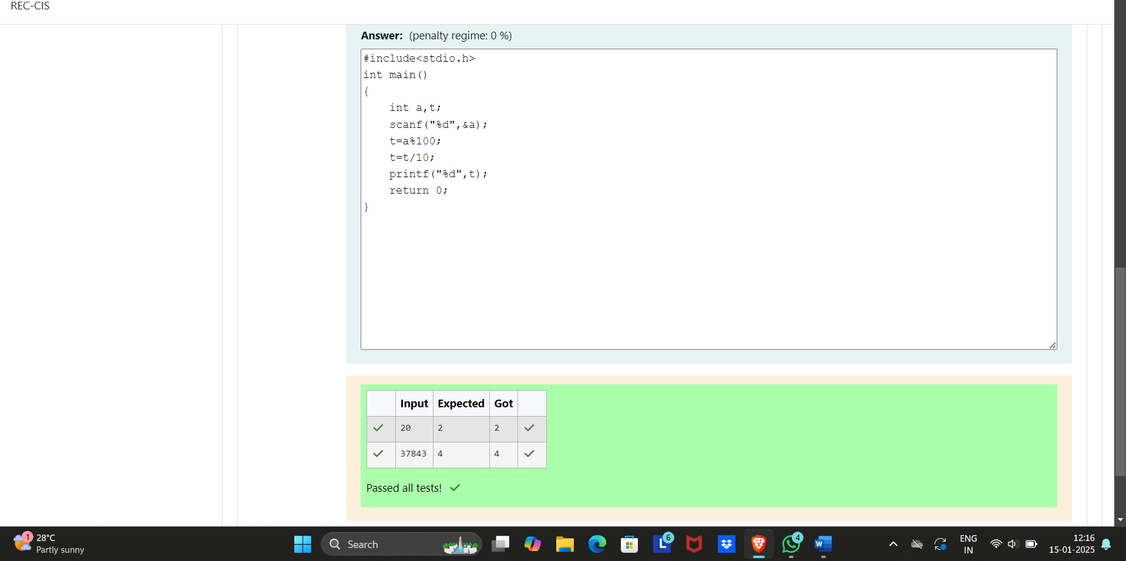

Q2)Write a C Program to calculates the area (floating point number with two decimal places) of a

Circle given it’s radius (integer value). The value of Pi is 3.14.

Sample Test Cases

Test Case 1

Input

7

Output

Area of a circle = 153.86

Test Case 2

Input

50

Output

Area of a circle = 7850.00

Test Case 3

Input

42

Output

Area of a circle = 5538.96

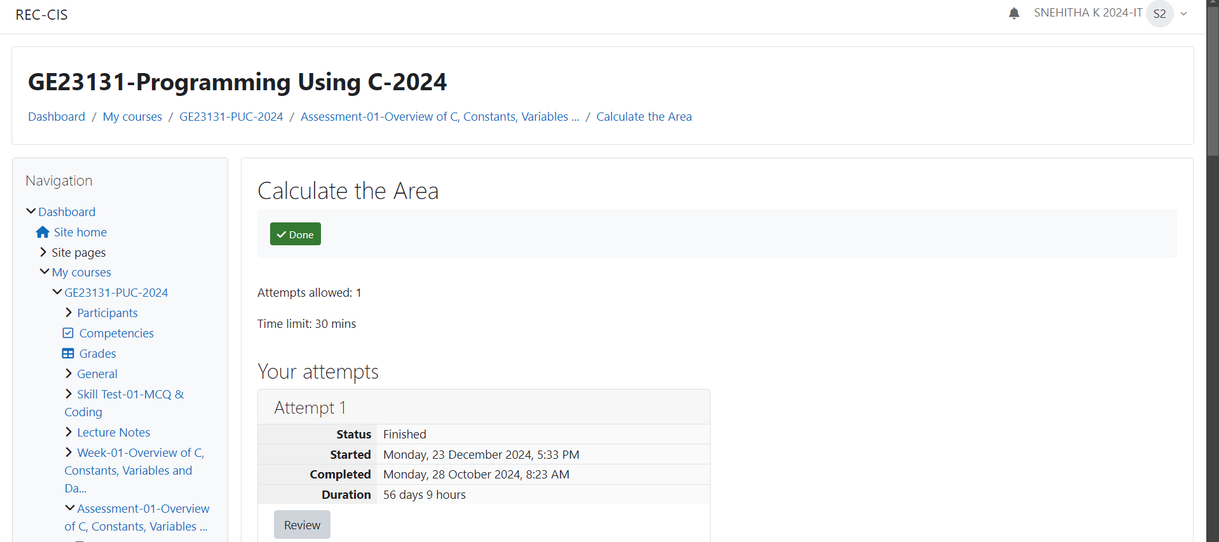

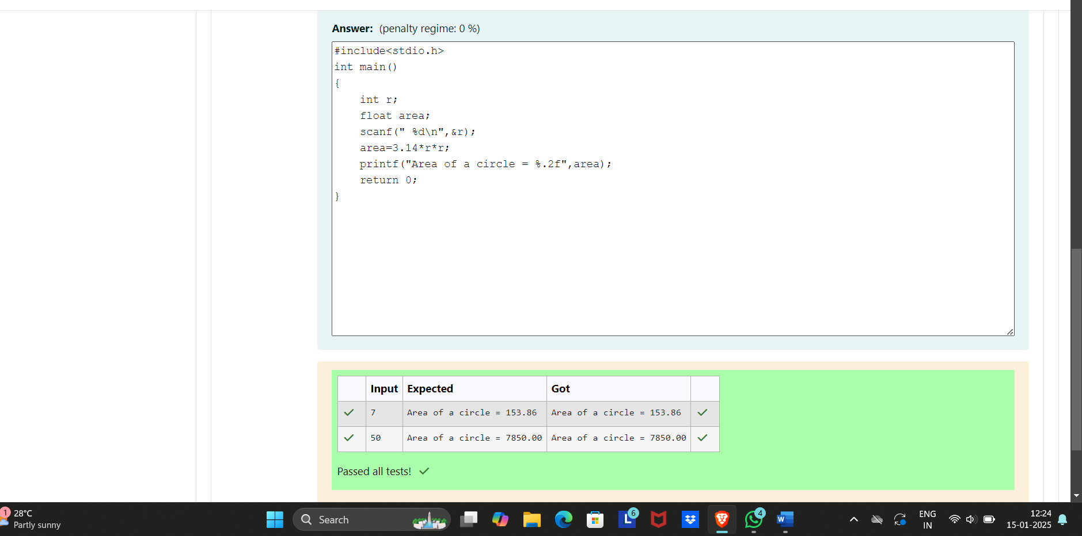

Q3)Develop a 'C' program to [swap](http://www.rajalakshmicolleges.org/moodle/mod/quiz/view.php?id=326) two numbers (using three variables).

Input

10 20

Output

Before swapping :

a = 10 b = 20

After swapping :

a = 20 b = 10

**For example:**

| **Input** | **Result** |
| --- | --- |
| 10 20 | Before swapping :  a = 10 b = 20  After swapping :  a = 20 b = 10 |

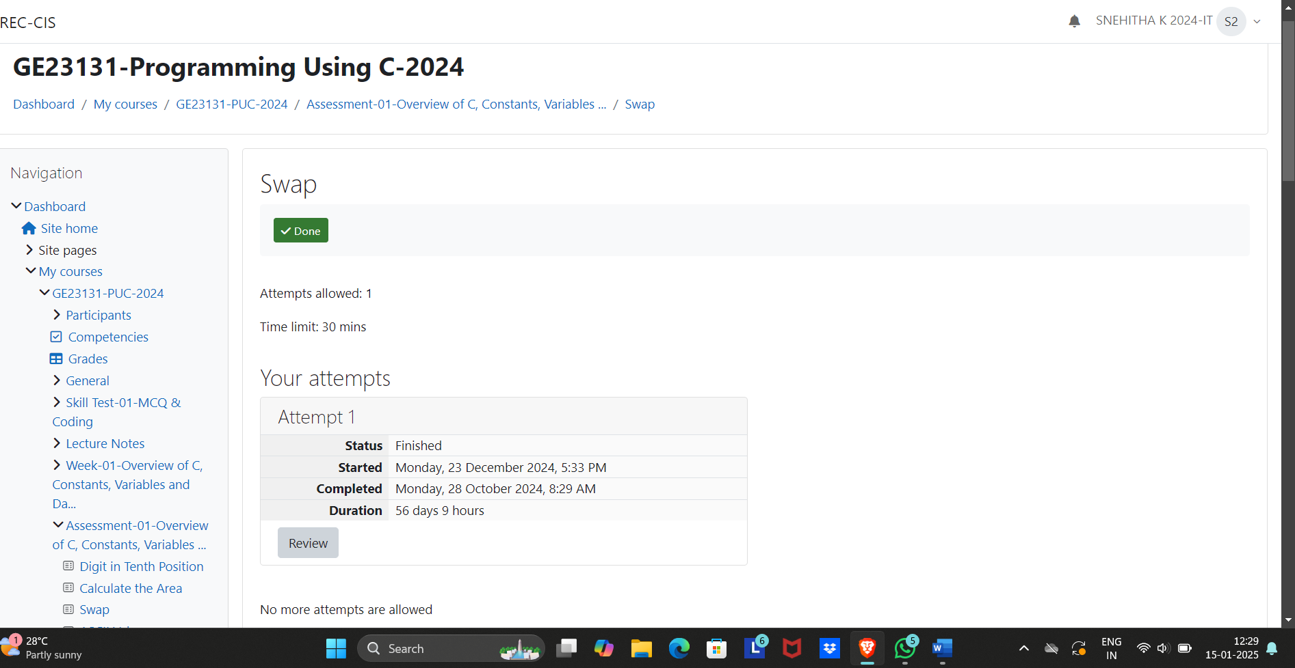

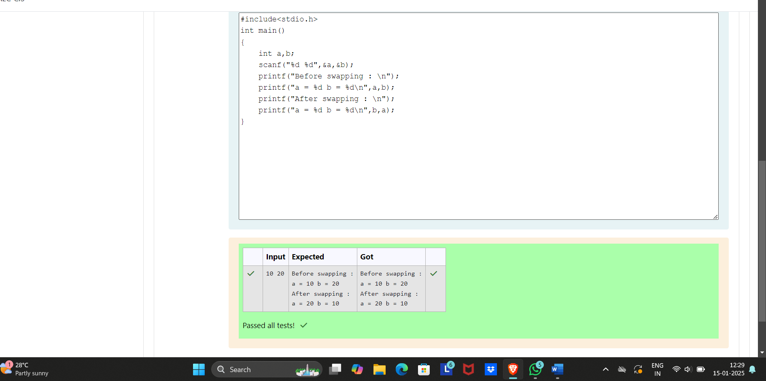

Q4)Write a program to print the [ASCII value](http://www.rajalakshmicolleges.org/moodle/mod/quiz/view.php?id=327) of the given character.

Input

A

Output

The [ASCII value](http://www.rajalakshmicolleges.org/moodle/mod/quiz/view.php?id=327) of the given character A is : 65

For example:

| **Input** | **Result** |
| --- | --- |
| A | The ASCII value of the given character A is : 65 |

